**IBM HR ATTRITION ANALYSIS**

**RESULT REPORT**

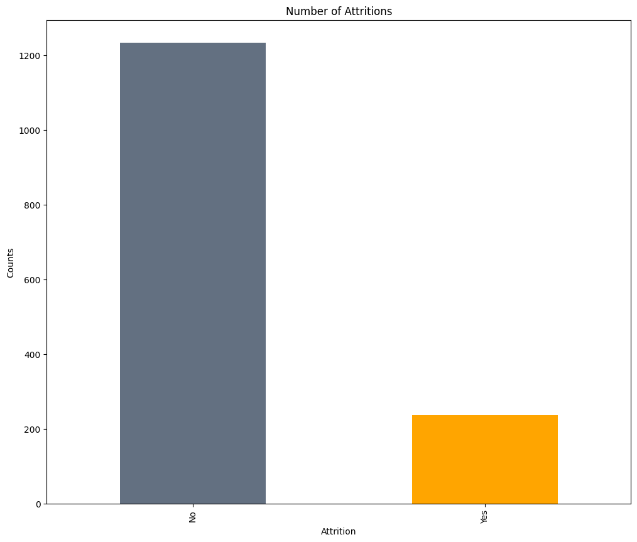

Number of Attritions in dataset, Attrition is less in dataset.

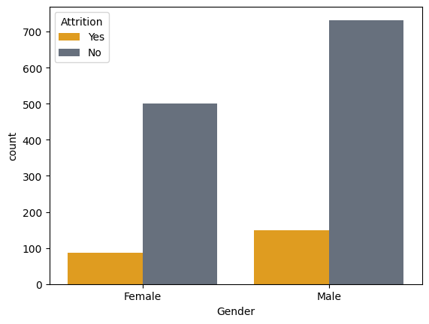

Attrition is higher in males than females.

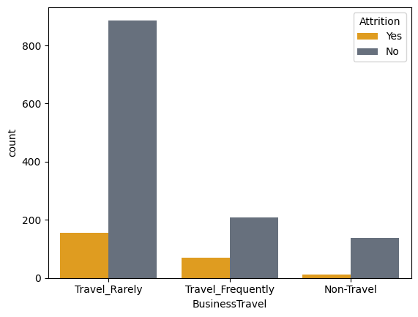

Attrition is higher in who travel rarely than who usually travel more.

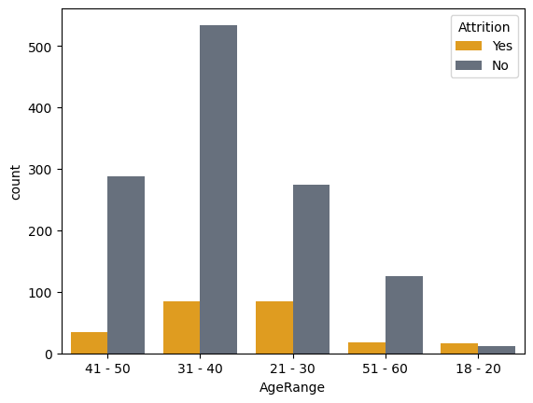

Attrition is higher in them whose age in range of 21 to 40.

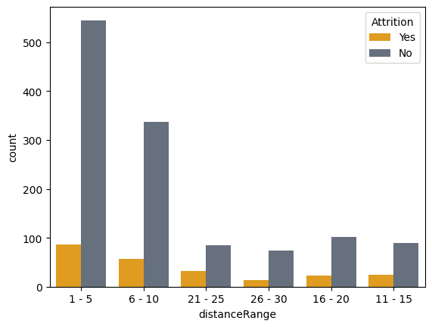

As distance increasing, attrition decreases.

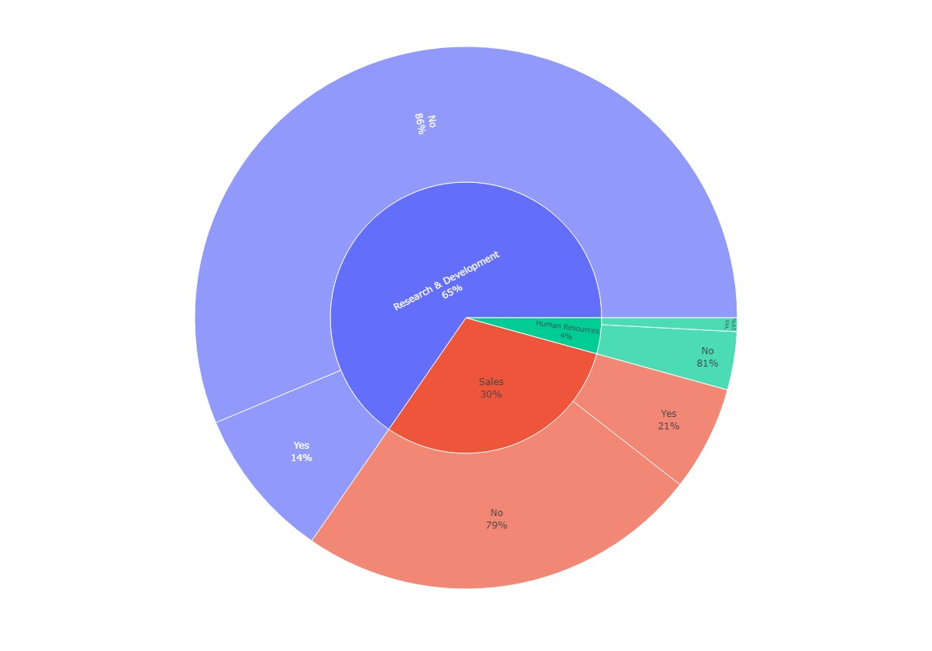

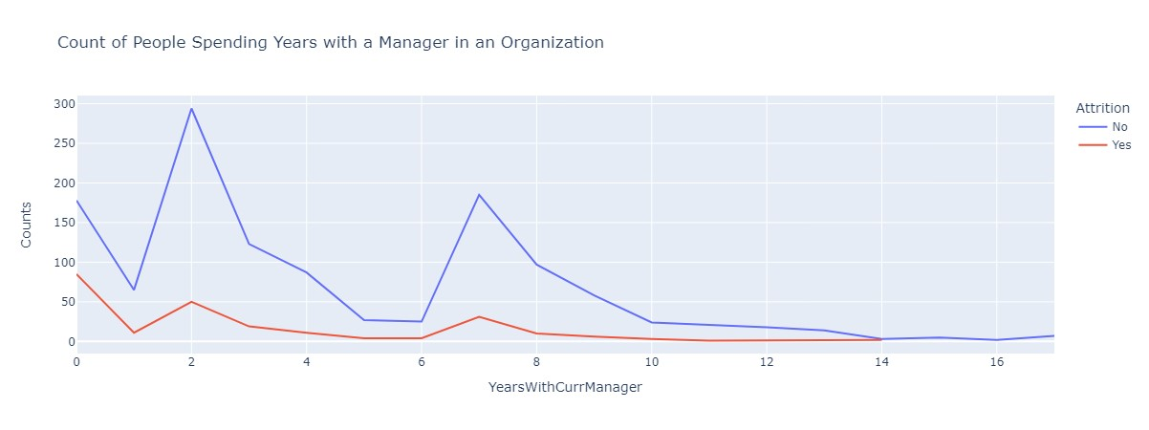

Attrition is little bit high who works with current manager for 2 Years and 7 Years.

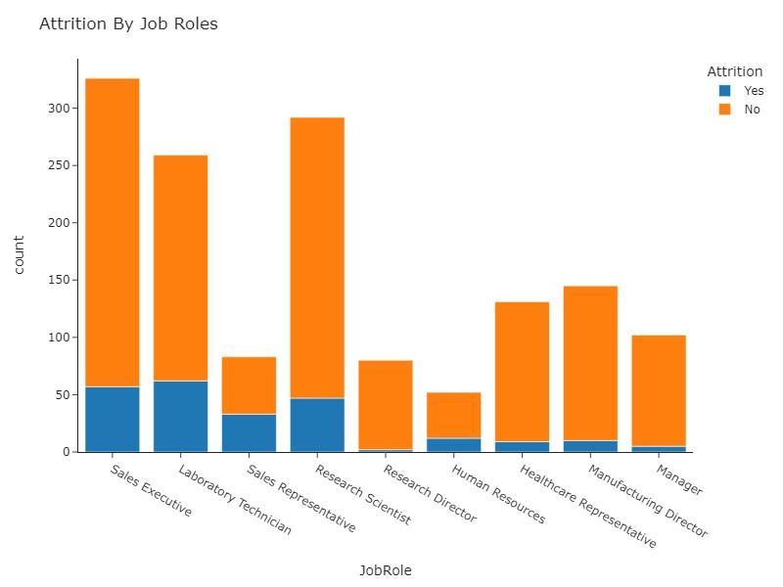

We have highest attrition in Laboratory technician and lowest in Research director.

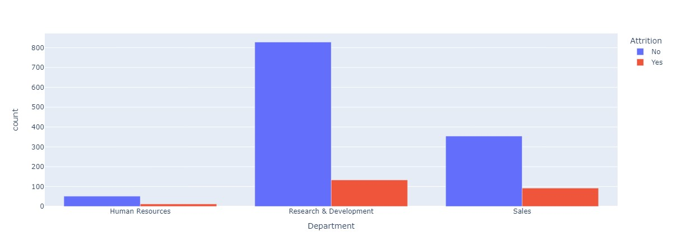

Highest attrition in Research & Development Department.

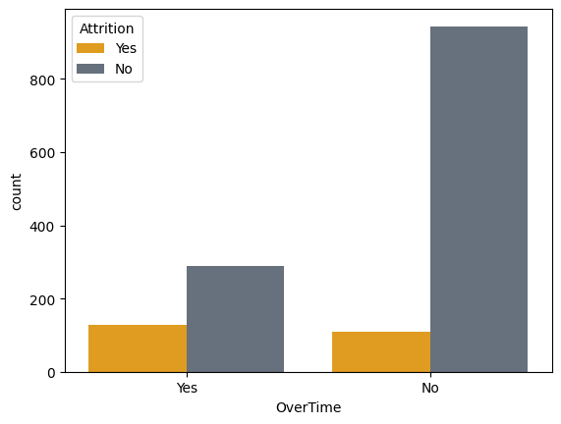

Less overtime stress peoples have high attritions.

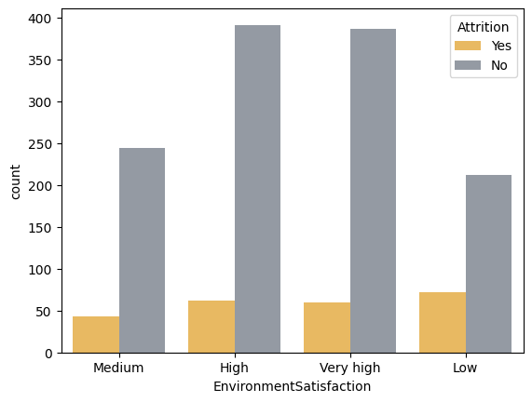

Highest attrition in low environment satisfaction.

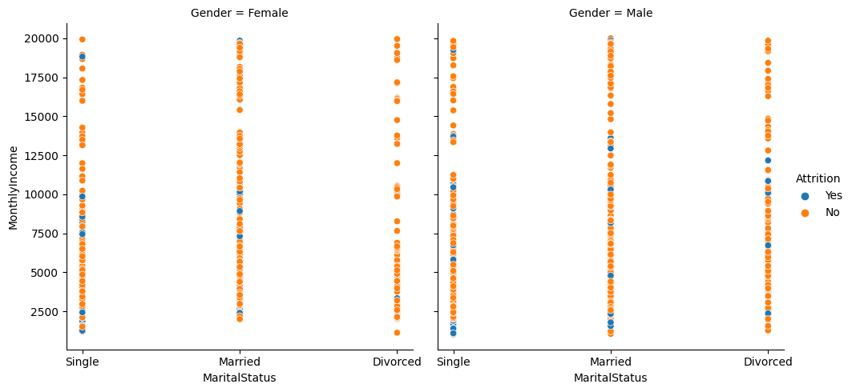

Attrition is much less in Divorced women.

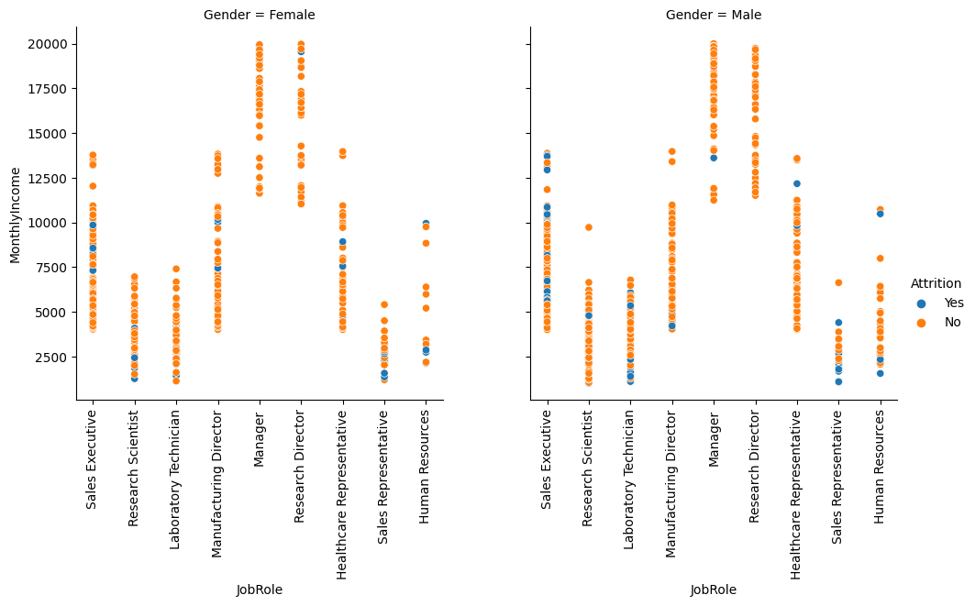

Women with the job position of manager, research director and technician laboratory have almost no attrition.